PAYMENT OF ARREARS

If you pass away, DFAS needs to know what you want them to do with your benefits that are due to you for the partial month in which you died.

The process is called Payment of Arrears and you can set up a beneficiary for these funds. This process will alleviate the confusion and delay of payment which will result if the beneficiary is not designated.

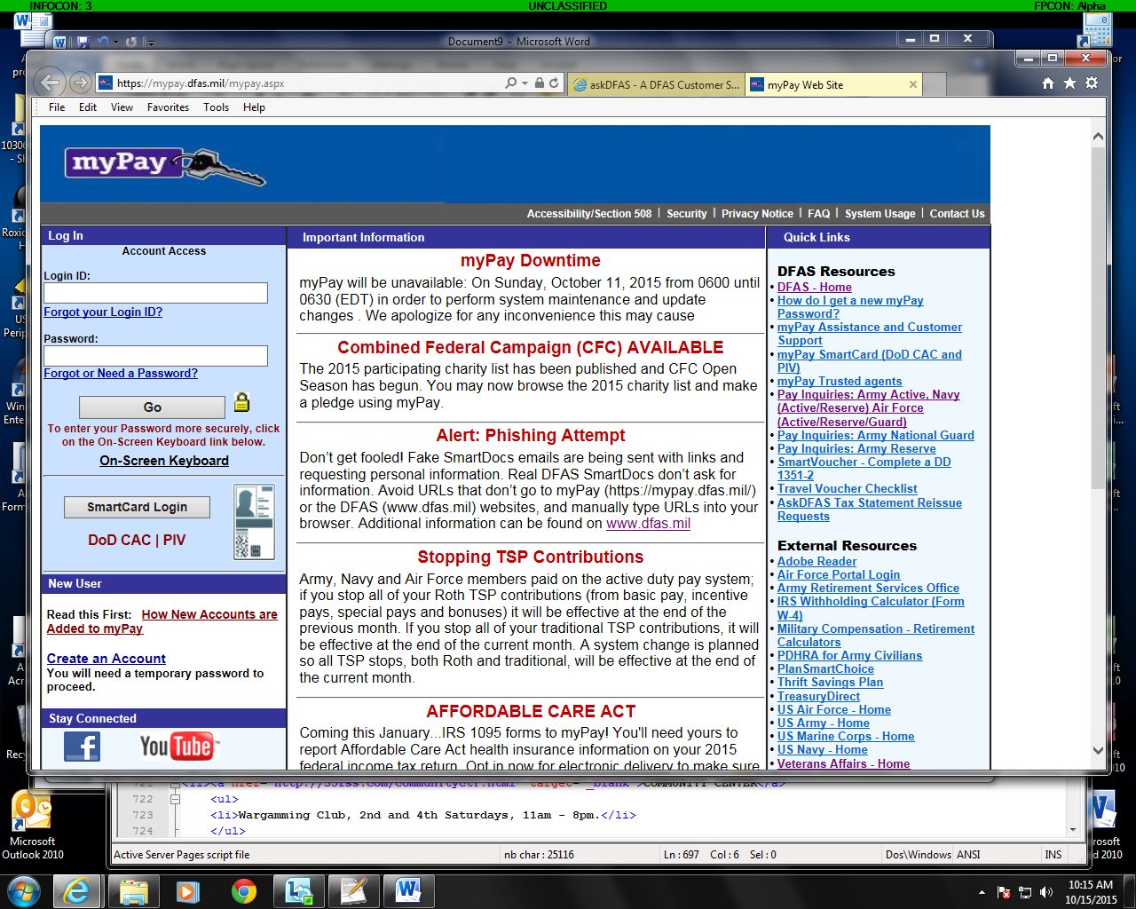

Agree to the terms of the User Agreement.

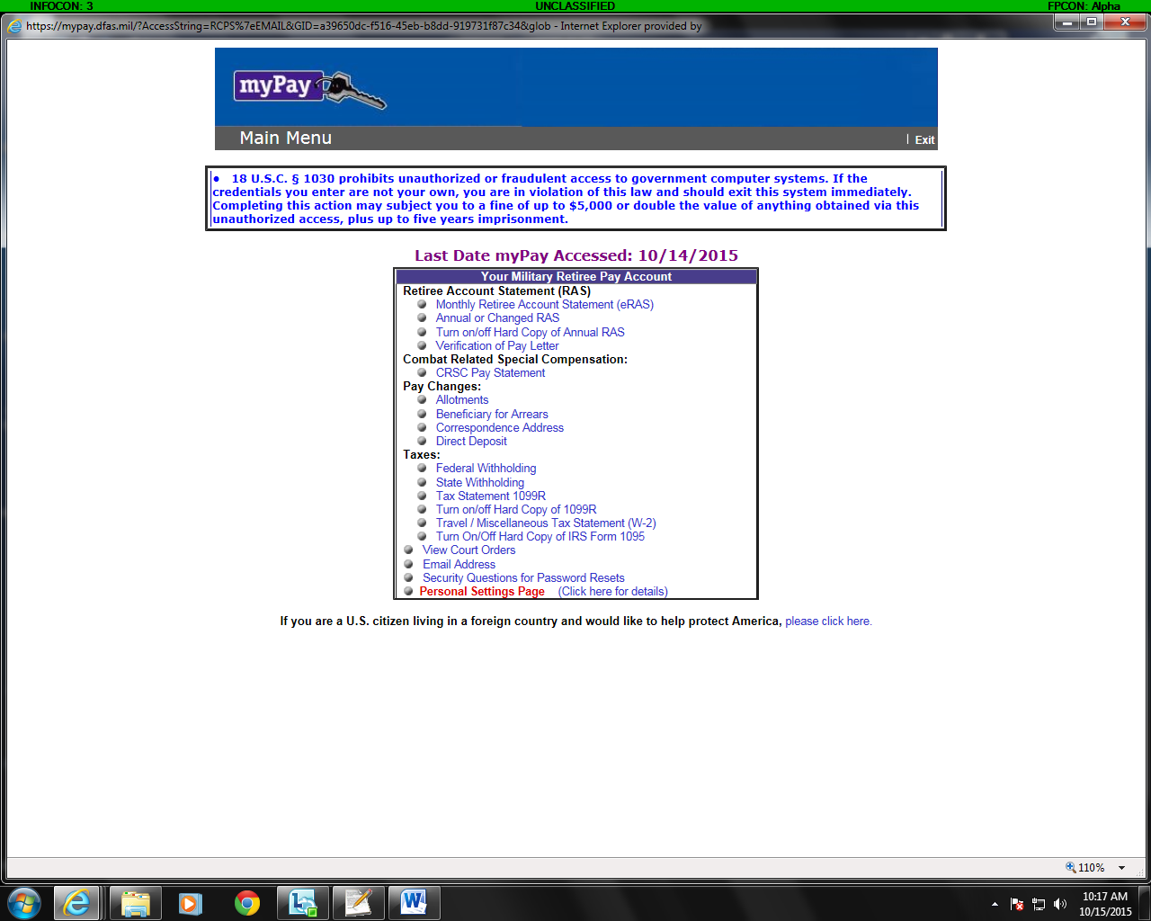

Click Beneficiary of Arrears and you will come to the following page.

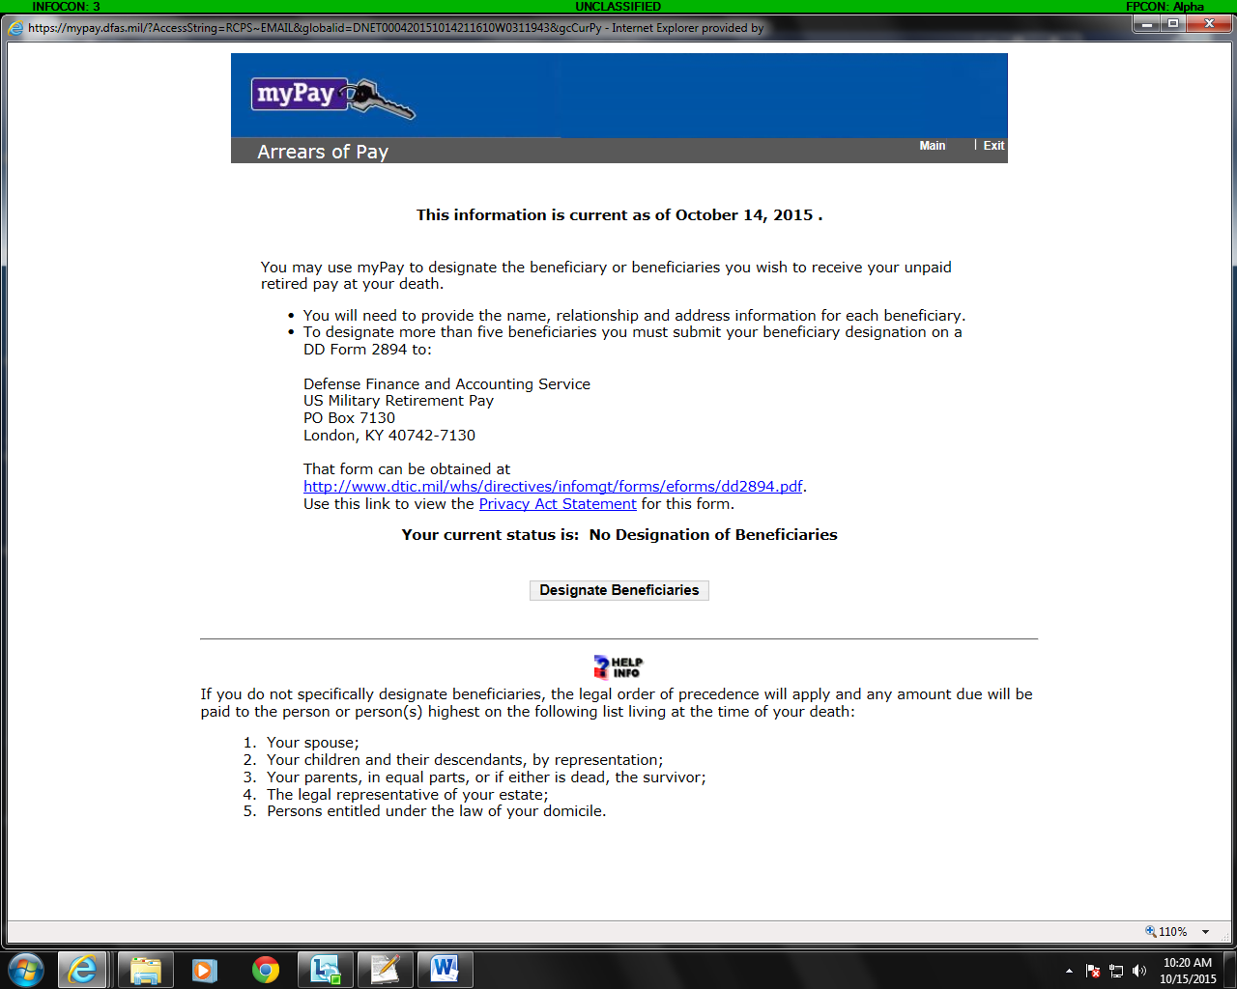

Now you can click the Designate Beneficiaries button and you will get the following page.

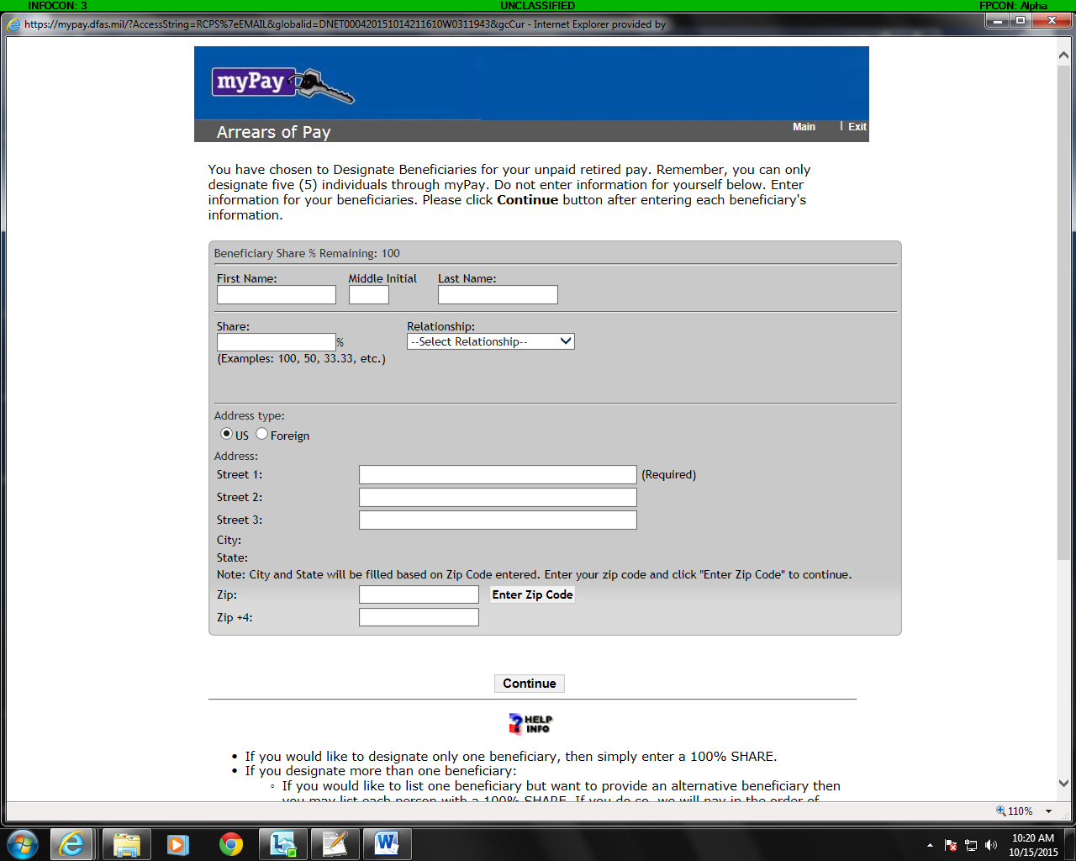

If you have a US address such as your APO address, you can fill out the form and submit it. However if you are using a local Japanese address you much click the Foreign button but it will lead to a problem.

When you click Foreign, the screen will change and you will get a drop down box asking for you country. When you enter Japan into this box, it will change the screen again and a data box will come up and ask to select a city from a list of Japanese cities. The problem is that there is no option for Oirase Chou, Misawa City, Rokunohe or any other Misawa area town/city. If you don’t choose one of the listed cities, you cannot submit the form.

The solution from the DFAS help desk is to submit a form via regular mail and have DFAS update your account.

To do this, go to http://www.misawarao.org/how_to/payment_of_arrears.doc. Once you open this form you can download it. Fill out the form as it applies to your situation and mail it to the Kentucky address shown on the rear of the form.

