SUBMIT A HELP REQUEST TO DFAS / MYPAY

Asking a question of DFAS and MyPay is not as simple as most web pages are. I have created a How To document with screen shots to help you get through the steps.

Open your web browser and type this into the address window:
https://mypay.dfas.mil

You don’t have to log on to send a question, just click Contact Us.

The following page will open. Click the ‘Contact Us” link (red arrow)

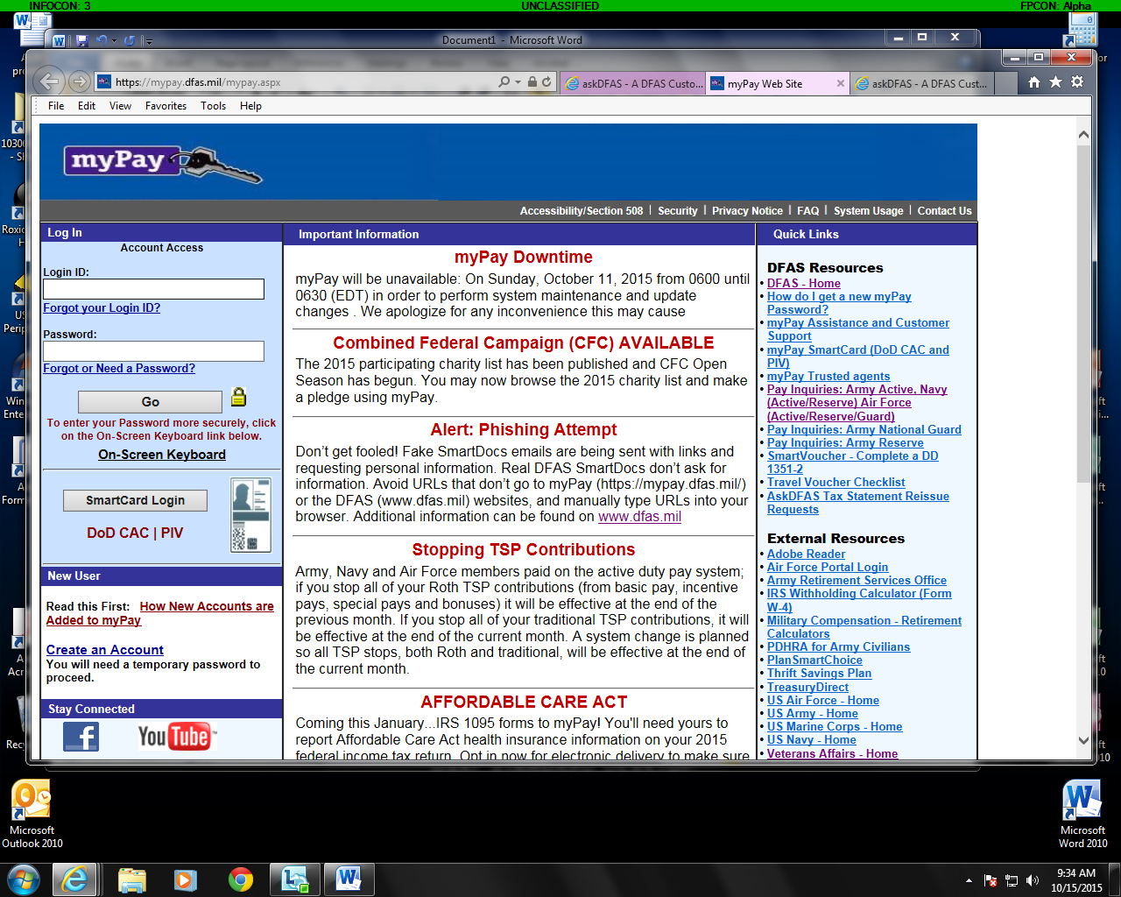

Click Agree on the DOD Consent pop-up window and you will see the following page:

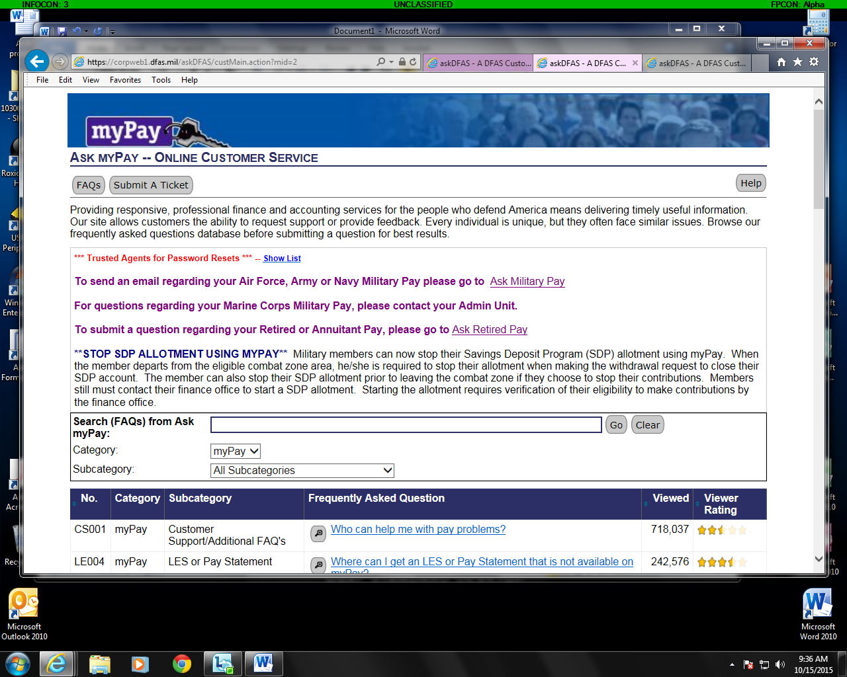
Click on the link for Ask Retired Pay

Once again, Click Agree on the DOD Consent pop-up window.

You will come to the following page:
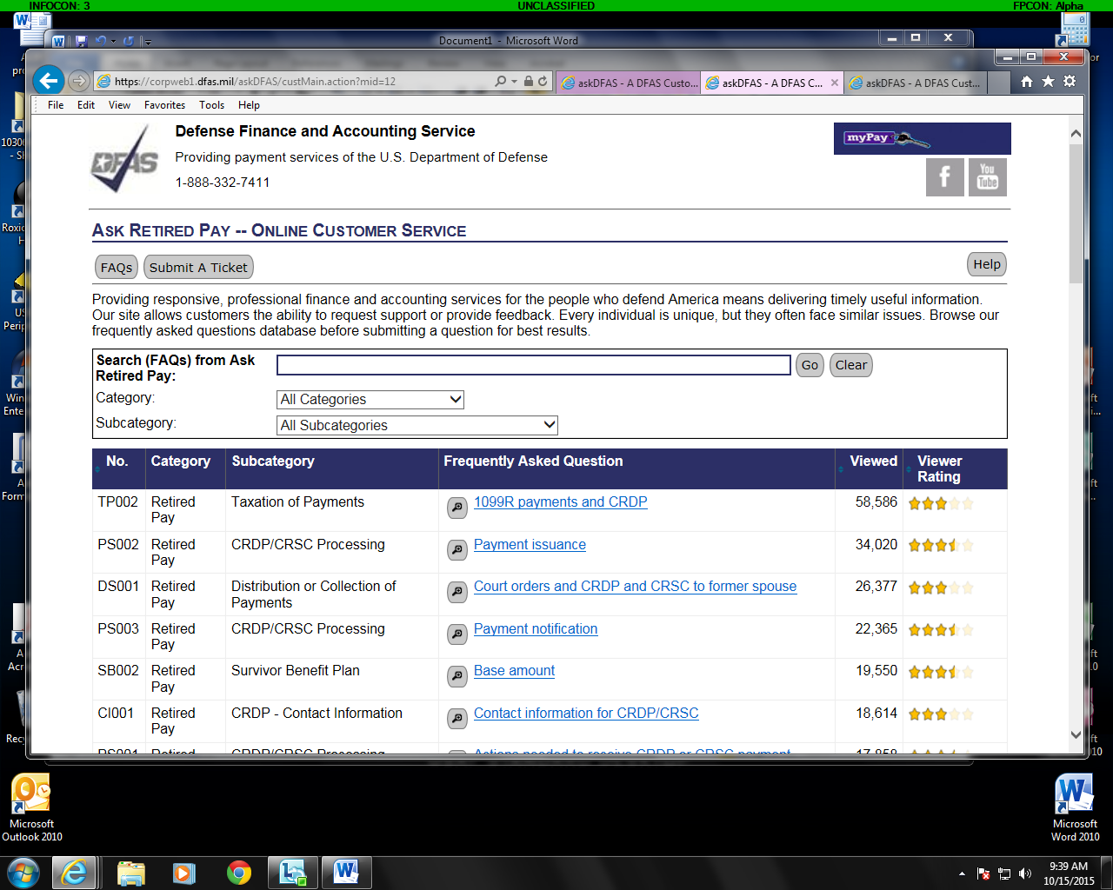

You can search the FAQs and then click on “Submit a Ticket or just go directly to submit a ticket.

Choose and click a topic for your question and then a sub-topic of applicable. Then complete the required info in the “Your Information” section.

You can add an attachment if you have a document you want to include the click the Submit button.

You will be asked to create a 4 – 10 digit access code. You will need this to access your reply. A pop-up will tell you your ticket number and other info. Write this data down and keep it.

You will receive also an email telling you your ticket number.

When you question has been answered, you will get another email with a link to a website you must go to so you can see your answer. Follow the link and enter you access code to see your reply.

