**BIOGRAPHY**

***U N I T E D S T A T E S A I R F O R C E***

**AVIATION WARFARE SYSTEMS OPERATOR FIRST CLASS (AW/NAC) (RET) GARY N. GRISHAVER**

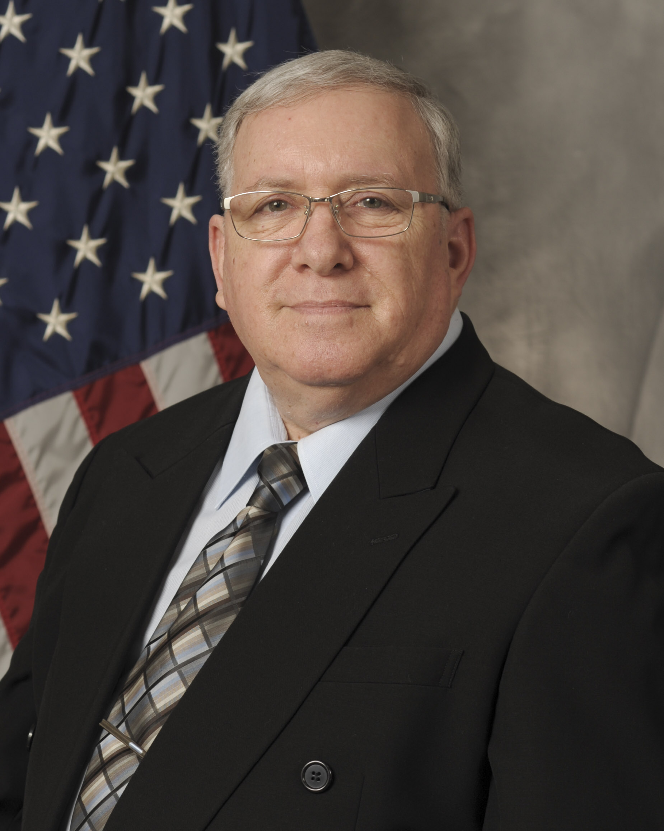

**Size:**

**2.75” x 3.5”**

**Position:**

**2.5” from Top**

**.5”** **from Right Edge**

Aviation Warfare Systems Operator (AW/NAC) (Ret) First Class, Gary N. Grishaver was at retirement the Recruiter Classifier of Navy Recruiting District New England, in Boston, MA. Responsible for working with Navy applicants, he would help find them careers in the Navy and process their enlistment paperwork. Additionally, he filled the role of Statistician by tracking all daily applicant processing and assigned mission goals. He is currently a volunteer at the Retiree Activities Office, 35th Fighter Wing, Misawa Air Base, Japan. He is responsible for providing assistance and information to approximately four hundred and fifty retirees, dependents and survivors of military retirees in northern Japan (to include the prefectures of Fukushima, Yamagata, Miyagi, Iwate, Akita, Aomori and the northern island of Hokkaido). He is responsible for assisting in casualty affairs, social security, tax preparation, and ensuring survivors of military personnel from all branches of service receive the benefits to which they are entitled.

Petty Officer Grishaver, a native of Randolph, MA. enlisted in the Navy on June 26, 1976. On January 11, 1977 he departed Boston, MA. to attend Recruit Training at San Diego, CA. Following Aviation Antisubmarine Warfare Operators “A” school at Memphis, TN, he attended Flight Training at Naval Air Station Jacksonville, FL. In January 1978, he reported to Patrol Squadron 24, Jacksonville, FL, where he flew on the P3-C Orion aircraft and worked in tactics. In September 1979, Petty Officer Grishaver transferred to the Antisubmarine Warfare Operations Center training school in Dam Neck, VA. In February 1980, he departed for Patrol Wing One Detachment Misawa, Japan, where he provided ASW mission support to forward deployed squadrons. In April 1984, he reported to Patrol Wing Ten, Moffett, CA, where he was selected to lead a Chief of Naval Operations (CNO) Special Project. In June 1987, he returned to Misawa, Japan, where he continued his work in Special Projects. In June of 1992, he departed for Pensacola, FL. to attend recruiting school. In September of 1992, he reported to Naval Recruiting District (NRD) New England and was assigned to the Navy Recruiting Station at Quincy, MA, where he served as an Enlisted Recruiter until his selection as NRD New England’s Recruiter/Classifier. On October 18, 1976 his retirement ceremony was held at Naval Air Station South Weymouth, MA. Petty Officer Grishaver, originally from Randolph, MA, resides in Misawa, Japan with his wife Atsuko (Yoshita) Grishaver and has five children: Randy, Matthew, Julie, Adam and Rika.

**EDUCATION**

1972 Massasoit Community College, Business Administration, Kingston, MA.

1978 Florida Junior College at Jacksonville, Business Administration, Jacksonville, FL.

1981 University of Maryland, East Asian Studies, Misawa, Japan

1999 Central Texas College, Associate of Applied Science, Misawa, Japan

**ASSIGNMENTS**

1. January 1977 - March 1977, Recruit, Recruit Training Command, San Diego, CA.
2. March 1977 - August 1977 Navy AW “A” School, Millington, TN.
3. October 1977 - December 1977 Flight Training, VP-30, Jacksonville, FL.
4. January 1978 - September 1979, Flight Crew, Patrol Squadron Twenty Four, Jacksonville, FL.
5. October 1979 - December 1979, Antisubmarine Warfare Operator School, Dam Neck, VA.
6. January 1980 - January 1980, Survival, Evasion, Resistance, Escape School, Warner Springs, CA.
7. February 1980 - April 1984, Analyst, Patrol Wing One Detachment, Misawa, Japan
8. April 1984 - May 1987, Analyst and CNO Special Projects, Lead, Patrol Wing Ten, Moffett Field, CA.
9. May 1987 - May 1987, Leading Petty Officer Management Training, Treasure Island, CA.
10. May 1987 – May 1987, Navy Drug and Alcohol Program Advisor School, Treasure Island, CA.
11. June 1987 - June 1992, Analyst and CNO Special Projects, Patrol Wing One Detachment, Misawa, Japan
12. July 1992 - August 1992, Enlisted Navy Recruiting Orientation, Pensacola, FL.
13. September 1992 – January 1997, Navy Recruiter and Recruiter/Classifier, NRD New England, Boston, MA.

**MAJOR AWARDS AND DECORATIONS**

Navy Commendation Medal

Navy Achievement Medal with one bronze star

Navy Unit Commendation

Meritorious Unit Commendation with two bronze stars

Navy Battle Efficiency Award

Navy Good Conduct Medal with four bronze stars

Navy Expeditionary Medal

National Defense Service Medal

Sea Service Deployment Ribbon

Navy Recruiting Service Ribbon

Overseas Service Ribbon with one silver star and 3 bronze stars

Navy Marksmanship Medal (Pistol)

National Defense Service Medal

Chief of Naval Operations Certificate of Merit for public presentations

Navy Recruiting Command badge with five Gold Wreaths

Enlisted Air Warfare (AW) Specialist Designation

Naval Aircrewman (NAC) Designation

(Current as of March 2021)